“AI for Beyond 5G Networks: Recent Advances and Open Issues”

# Abstract:

The technology is alternating our existence with its revolutionary speed and responsiveness. The conversation industry is swiftly progressing toward 5G and beyond 5G (B5G) Wi-Fi technology an effective way to fulfill the ever-growing demands for better facts fees and stepped forth quality-of-carrier (QoS). Rising programs require Wi-Fi connectivity with pretty improved information fees, appreciably reduced latency, and arising assistance for massive quantity of devices. Those necessities pose new challenges which could not be addressed via traditional tactics. Therefore, Artificial Intelligence (AI) is taken into consideration as one of the most promising solutions to enhance the overall performance and robustness of 5G and B5G structures, fueled via the large amount of statistics generated in 5G and B5G networks and the availability of powerful records processing fabrics.

This paper summarizes the modern day AI-based Beyond 5G strategies at the set of rules, implementation, and optimization degrees. Furthermore this paper sheds mild at the blessings and limitations cutting-edge AI-based answers, and summarizes modern day emerging strategies and open research issues. This paper speaks some issues that 5G will nevertheless leave open, and the feasible evolution towards the following generation (6G) of wireless conversation systems.

**Introduction:**

As a result of growing demand, communication networks continue to increase, in particular due to ever-developing numbers of Wi-Fi customers and new rising wireless offerings. Speedy implementation and dissemination of various packages has enhanced consumer demand forcing cellular operators to decorate their network infrastructures. This environmental change calls for a whole rethinking of community deployment. Consequently, many 5G activities persist, in spite of the first deployment of 5G networks already underway. In the coming days, it is possibly inevitable that users will demand extra worldwide coverage, better records fees, and omnipresent availability of the latest and destiny internet offers and programs. Hence, modern-day 5G technology needs to be further developed in line with 6G standards to reach those requirements.[1]

Artificial Intelligence (AI) and Machine Learning (ML) are the fasted developing, most requested methods for the improvement of data and communication innovation. AI is “the simulation of human intelligence processes by machines, especially computer systems”.[2] It is also described as the science of creating computer systems carry out obligations which requires intelligence like humans. AI is a border concept of cleverly machines that can recreate human considering capability and behavior, while, machine learning is a current (most popular) application of AI that permits machines to memorize from information without being modified explicitly.[3] The objective of ML is to permit machines to examine from information so that they can allow precise yield. AI is rather large in nature, although there is a broad room for machine learning. AI operates to create an intelligent device capable of performing various complicated jobs while machine learning operates to create machines capable of performing only those particular tasks they are equipped for. AI incorporates learning, thinking, and self-correction, while when implemented with new data, ML incorporates learning and self-correction. Deep learning studies artificial neural networks (ANNs) (kind of algorithm aimed at imitating how our brains make decisions) as a unique form of ML, which compromise more than one covered up layer to “simulate” the human brain Fig [1]. Deep learning is currently one of the most commonly used ML approaches, since it has been efficiently applied to numerous fields consisting of computer vision, speech popularity, and bioinformatics.[4] If we get a new knowledge, the brain tries to equate it to a known object before it becomes meaningful-which is the same principle used by deep learning algorithms.[5]

AI will not supplant people, but really can assistance us. AI will empower us to spend more time on high value-assignments, instead of investing time on overseeing and analyzing. Transaction task automation can reduce the amount of time spent on data processing, on a wide scale.[6]

AI is now being incorporated into networks, with a primary emphasis on minimizing capital spending, improving network efficiency and creating new revenue streams. AI will be crucial for progressing client benefit and upgrading client experience Fig [2]. AI will provide assistance to recover the investments made by communications service providers (CSPs) to 5G network exchange. Adopting AI is making modern information challenges, indeed because it addresses issues in the network.[7]

As a standard AI technology, ML is widely expected to unexpectedly emerge as a key problem of communicating B5G networks. In order to address the difficulties of developing and operating B5G networks, it must make good use of the big details.[8]

Present mobile networks, built and operated on the basis of previous postulates, that systematically fail to allow future communication services, as they cannot keep up with the data explosion and the underlying complexity of the produced data while ensuring the desired capacity, reliability, and adaptability.[9] The network therefore cannot respond rapidly and predict incidents that could potentially deteriorate real-time communication services. Nonetheless, most AI algorithms and applications are not designed specifically for wireless communication networks, making it difficult to apply existing AI algorithms directly to B5G networks.[10]

AI and its sub-categories such as machine learning and deep learning have developed as a discipline, to the extent that this process nowadays allows wireless networks of 5G to be predictive and adaptive, that’s crucial in making the 5G imaginative and prescient conceivable. In the context of B5G mobile and wireless communications technologies, an overview of the potential of AI based solutions is addressed, analyzing the different problems and opening themes for future study. [11] Eventually, this paper explores the possible characteristics of B5G, offering future directions for research on how ML can lead to the realization of B5G.

**CHANNEL MODELING AND MEASUREMENTS OF B5G NETWORKS USING AI TECHNOLOGIES**

**Channel Measurement Data Processing and Channel Modeling:** The range of frequency bands, including sub 6 GHz, millimeter wave (mm Wave), terahertz (THz), and optical bands, has made channel design more challenging for B5G wireless communication systems. The current channel models are expanded with a much higher computational complexity to meet the criteria for the B5G Channel modeling. Channel measurements must be performed while modeling for new situations to consider new channel characteristics, which is a time consuming process.[12] In addition to a recent study [16], there are very few studies that have examined the benefits of applying AI to channel modeling and most of the current works only use very basic AI techniques on a very small part of the channel modeling method. There is no research that explores the use of AI technologies to channel measurements in detail.[13]

Because of the high difficulty of modeling the sign propagation in various situations, traditional approaches make several assumptions and approximations to simplify the approaches of processing and modeling.

Wireless channels features can be extracted from the high quality of existing dimension facts and, at the same time, the channel modeling issue can be approached in a data driven way, integrating seamlessly with model-based approaches. This should achieve a strong balance with the precision-complexity trade-off of both processing and modeling techniques.[14]

ML can be applied to predict channel characteristics, model channel impulse response (CIR), cluster multi-path component (MPC), estimate channel parameter, and classify scenarios based on channel size records and surroundings information.[15] In the survey “A Big Data Enabled Channel Model for 5G Wireless Communication Systems” the researchers suggested a broad data-enabled channel model related to both feed-forward neural network (FNN) and radial basis function neural network (RBF-NN).[16] Hence, channel statistical properties consisting of the obtained power, root mean square (RMS), delay spread (DS), and RMS angle spread as (Ass) with transmitter (Tx) and receiver (Rx) input parameters, Tx-Rx size, and provider frequency can be expected. The FNN and RBF-NN performance was thoroughly compared based on each actual channel dimension records and synthetic facts. Thus, in the Fig [3] and Fig [4] the measured and predicted path loss and RMS DS is proven exhibiting true achievable for channel modeling respectively. In the survey paper “Data scheme-based wireless channel modeling method: motivation, principle and performance”, the ANN turned into carried out to take away the noise from measure CIR, and the main component analysis (PCA) was used to manipulate the channel and model the CIR features and structures.[17] Likewise, in the survey “Clustering Enabled Wireless Channel Modeling Using Big Data Algorithms”, various clustering algorithms for MPC and monitoring were investigated including K-means, fuzzy C-means (FCM), and density based spatial clustering of noise applications (DBSCAN).[18] In the survey “Wireless Channel Feature Extraction via GMM and CNN in the Tomographic Channel Model”, the convolution neural network (CNN) was used to mechanically perceive extraordinary Wi-Fi channels and aid in determining which wireless channel features to use. In the CNN the MPC parameters such as amplitude, delay, and Doppler frequency were extracted and utilized as enter parameters, and the CNN output was the wireless channel class.[19]

**Channel Estimation Associated with ML**: In Wi-Fi communications, the channel state information (CSI) may be acquired using blind and pilot-based channel estimation techniques. Nonetheless, the calculation of blind channels derives statistical properties through the use of abundant obtained symbols.[20] With the use of 5G key technologies for pilot based technique, pilot overhead, non-linear channels, and high level of versatility, etc., are obstacles to be addressed in channel estimation.[21] The pilot overhead, for example, could be unbearable for massive multiple-output (MIMO) channels and ultra-dense networks (UDNs). As a result, the trade-off among pilot length and accuracy of the channel estimation must be taken into consideration. As a result, the alternate-off among pilot length and channel estimation accuracy must be taken into consideration. The non-linear characteristics of visible mild communication (VLC) channel and mm Wave channel make it hard to get correct CSI. The non-linear features of the Visible Light Communication (VLC) channel and mm Wave channel make accurate CSI difficult to obtain.[22] Moreover, with the development of high speed railways(HSRs), accurate channel estimation is critical to ensure quality of service (QoS) and efficient facts transmission.

To solve the above-mentioned problems, researchers use ML strategies. A two-dimensional (2D) non-linear complex support vector regression (SVR) based on an RBF kernel was proposed to achieve an accurate channel estimate in order to resolve the channel estimation in a rapidly fading time-varying multipath domain.[23] In the survey “Deep Learning-Based Channel Estimation for Beamspace mmWave Massive MIMO Systems”, for beamspace mmWave large MIMO systems a deep learning based channel estimation algorithm has been proposed. [24] It can learn the structures of the channels and estimate channel from a large wide variety of education data. Furthermore, in the research paper “Off-Grid Sparse Bayesian Learning-Based Channel Estimation for MmWave Massive MIMO Uplink, for mmWave massive MIMO uplink, an off-grid sparse Bayesian learning based channel estimation algorithm has been proposed .By exploiting spatially sparse structure in mmWave channels, it can define the angles and gains of the scatter paths.[25] One potential path for this subject matter is the generalized ML-based channel estimation scheme which can be used directly without further training in different scenarios. To construct this generalized scheme, machine/deep learning algorithms must be a large amount of pre-collected communication data to learn the channel function of several surroundings.

**PHYSICAL-LAYER RESEARCH FOR B5G NETWORKS USING AI TECHNOLOGIES**

**Large-scale sensing via Massive Radio Interfaces:** Using wide antenna arrays not only gives the unparalleled efficiency in phrases of reliable and high-rate communications (as exploited in big MIMO), however, also provides vast quantities of baseband-stage facts that may be used to make inferences about the surroundings. Emerging extra novel use cases involve inferential issues such as detecting the existence of shifting objects, estimating the quantity of traffic on a route, counting of the wide variety of individuals in a room, or preventing intrusion into covered spaces. The sensing of open spaces, indoor environments and even through-the-wall are specific technological challenges that lie within scope. There are rising business use instances and additionally many purposes in security, surveillance, and monitoring.[26]

ML algorithms in particular are suitable for analyzing vast amounts of data produced by large gain antenna arrays, specifically massive MIMO arrays, as commonly parametric models are inaccessible or unreliable and thus classical estimation/detection algorithms are inapplicable. More precisely, deep learning networks and methodologies from image processing and video analytics can provide the most promising direction in terms of algorithmic approach. It is crucial to word the difference between traditional radar imaging, wherein the aim is to construct a picture or map of the surroundings, while the objective of rising large-scale sensing is to extract basic characteristics of environmental dynamics and make interferences about unique phenomena.[27]

Essential future research directions will include both appropriate physical modeling work and the creation of an algorithmic framework that utilizes the available ML tools. Civilized deep neural networks are important technology problem in this regard; nonetheless various forms of dictionary mastering can also be used in addition. Simulated channel models need to be used for assessment alongside with experimentally gathered actual data. Working along these lines and using these approaches could dramatically advance the state-of-the-art in sensing open spaces, and through-the-wall and function inferential duties impossible with conventional model based signal processing. Any other application that can experience the era is gesture popularity if sensing is implemented at better frequencies.

**Signal Processing:**

The implementation of large MIMO technologies in 5G networking networks is one of the apparent use instances that AI can be deployed. Despite the fact that huge MIMO has many benefits, along with flexibility of the spectrum, energy efficiency, protection and robustness, it may generate a huge quantity of information.[28]

For instance, a massive MIMO device with 32×56 antennas and 100 MHz bandwidth will generate data exceeding 32 Gbytes in channel measurements. With large massive MIMO systems, both the detection and channel estimation are typically time-consuming techniques and need outstanding computational energy. Massive MIMO system’s huge data property lets investigators think about the ML techniques.[29] In the survey “Applicability of big data analytics to massive MIMO systems”, large random matrices represent the huge amount of data produced from the massive MIMO network, and are analyzed using the single ring law. Pilot interference is one of the problems for massive MIMO system, which can have a huge effect on the efficiency of massive MIMO systems.[30] The pilot infection stems from the pilot interference among adjoining cells and might restrict the ability of systems to attain accurate CSI. As the number of antennas increases, channels in beam space are roughly sparse, i.e., maximum MPC electricity comes from a few paths produced in space clusters, and a small number of non-zero elements are included in the channel matrix.[31] The researchers in “Channel Estimation for Massive MIMO Using Gaussian-Mixture Bayesian Learning”, acquire the CSI of massive MIMO systems using the Bayesian learning method, based on the sparse property of channels in beamspace.[32]The Bayesian learning approach will produce a better performance in terms of pilot contamination as opposed to the traditional CSI estimators. The sparse healing problem for the Bayesian compressive sensing is a vital research topic. It target to estimate a compressible non-negative vector from a set of noiseless measures.

**Data-driven Localization in Wireless Networks:** Exact positioning is useful for network management and services centered on context awareness and distance. Many existing wireless positioning strategies use information from the network and fingerprints to predict positions. In fact, the channel facts want to be periodically modified to represent the actual channel traits considering they may be liable to ramification of dynamic and time-varying impediments to transmission, such as path loss, interruption and blockage. This frequent, long-term renovation is time-consuming and labor-intensive, particularly for B5G systems of large scale. Data-driven localization is a promising approach, i.e., positioning devices and users by learning from raw sensing and communication data with ML algorithms, as the amount and complexity of sensing and verbal exchange records in the B5G systems significantly increase. In addition to being self-adaptive to the real time dynamic transmission impediments, the data-driven localization algorithms will also evolve over the years by always mastering from records. The locations of wireless channels can be constantly monitored and enhanced by automatically learning from a wide variety of cellular devices from the crowd-sourced huge data. Users will enjoy better location-based services in return, taking advantage of the precise localization results.

**AI ALGORITHMS AND APPLICATIONS FOR B5G NETWORKS**

**Distributed ML Algorithms for B5G Networks**: Signal processing and ML algorithms are usually implemented in existing communications applications central. Architecture of the network is the Cloud-Radio Access Network (C-RAN), where specific estimates are made and data processing is carried out on a central unit (e.g; cloud) for all networks devices. However, in the presence of massive number of devices and connectivity limitations on the fronthaul/ backhaul connections, various network functions should be performed locally or with limited cloud trade of information. Hence, the provision of a decentralized useful architecture, which adapts dynamically to the community requirements, is of central importance.[33]

As illustrated in Fig.5, Light-weight deep gaining knowledge of model can be carried out to cloud, fog, and aspect computer networks.

The cloud community is the storage and processing center, there are many nodes in the fog network, and threshold network incorporates enormous and customers and devices. At the same time, there is the want for decentralization learning, classification and signal processing algorithms that adapt seamlessly to the number and the kind of information sources, thinking about the available communication bandwidth. The advantages of decentralized and centralized algorithms should be balanced it he context of a dynamic edge computing system, thus the trading-off complexity, latency, and reliability. This requires for the introduction and further improvement of techniques for records fusion, compression, and dispensed decision-making.

There is also a need to build approaches in the distributed setting that are capable of understanding the relationships between the networks entities and their evolution. Due to the fact that dynamical network interference is generally a complex challenge in general, scalable answers are needed. The ability of online learning methods, such as kernel-based adaptive filters, high-dimensional Set-theoretical algorithms, and other robust statistical estimation methods, must therefore be evaluated. Specific examples include Bayesian procedures in combination with indirect methods of inference, such as indirect methods of inference, such as indirect forwarding of messages and generalizations.

**ML Algorithms for Ultra-fast Training and Inference:** ML algorithms are designed mainly for systems and applications which do not want to obtain high frequency powerful results. Lamentably, this is not always the case in the sense of B5G networks, which for ultra-low latency must guarantee excessive statistics processing rate. This enforces a strict restriction on training speeds and, in particular, on ML model inference. Hence, one major challenge is to advance ML algorithms with ultra-fast education and inference functionally for destiny wireless communications. There are two plausible instructions to speed up ML coaching speed. One is imposing hardware-based ML algorithms which must lead to low energy consumption and high efficiency. The other alternative is to reduce the complexity of ML algorithms by maintaining a rational precision.

**Light-weight ML Algorithms for Universal Embedded Systems:** Present ML algorithms concentrate primarily on computer vision, natural language processing and powerful graphics processing unit (GPU) or central processing unit (CPU) allowed computing to run in real time.[34] Communication networks, however, are complete of aid-restrained gadgets, e.g; embedded and IoT-systems. The ML communications algorithms can therefore not only learn complex mathematical models that underlie networks, customers and devices, but also operate efficiently with embedded devices that have restricted storage capacities, computing capacity, and power resources. Developing light weight ML algorithms, particularly deep learning models, for embedded systems is challenging but highly rewarding. In this dimension, the combination of ML and the distributed computing frameworks such as fog computing and edge computing will be one possible path. Some other vital lookup direction is the investigation of high-level ML improvement library and toolbox.

**A vision of 6G/B5G:**

Below are the lists of some alternative evidence that may occur:

**1.Excessive data:** At our current speed (2020), about 2.5 quintillion bytes of data generated every day, but the rate is only increasing with the development of the Internet of Things (Iot) [See Fig.6][35].Over the last two years, 90 per cent of the world’s data was produced alone .[36]

The volume of data shared via smartphone users will maintain to upward thrust, on the only hand due to growing quantity of linked non-human devices (including cars, UAVs and self-sustaining systems) and the improved standard of 3D video / holographic form contact that would be used by humans.

**2.Network Intelligence:** The mobile network must become smarter to cope with increased demand, with learning processes to autonomously change themselves based on understanding of the consumers, situation-conscious decision-making and networking [see Fig.7].

**3.Rapid reallocation of bandwidth.** Network expertise can be used to enable fast and efficient allocation / reallocation of the spectrum, with the resulting high bitrates ac**cessible to consumers.**

**4.Empowered senses:** To enhance the level of tele-interaction, other human senses should be shared including 3D/holographic form contact, flavor, smell, touch.

**5.Wi-fi-gadgets-as-a-carrier**: customers will no longer always need to convey a smartphone but will reward of wireless-devices-as-a-service, with disbursed devices useable to every person. All records being within the cloud, users will just want to be authenticated and then get right of entry to the community by way of the usage of any available tool.

**6.Battery life & power:** The need to refresh batteries would be significantly reduced, thereby greatly increasing the battery existence.

**7.Quantum devices & networks:** We can see the emergence of quantum machines, capable of solving nonquantum computing problems. Quantum conversation and networks will also be functional, e.g. from satellites, for the cryptographic key exchange.

**8.Privacy, protection, facts, and manipulation:** The call for protection and confidentiality should be of utmost vital for the proper handling of personal data. The advent of quantum devices would require a reconsideration of the processes of cryptography and security.

**9.Security and Safety:** IOT and Industry 4.0 are going to carry the network very loose to the actual infrastructures. Therefore, a security compromise on the networking side will also easily become a very serious safety problem in actual life.[37] It has also occurred in August 2017 with the botched assault on a petrochemical plant in Saudi Arabia, which is generally suspected to have been directed at making the plant collapse by targeting the facilities for IT power.[38]

**10. Explosion of Virtual Operators:** NFV-SDN technology and associated slicing capabilities would accelerate the proliferation of virtual operators competing by providing customers with added value services by implementing advanced network features in the cloud. This can contribute to major progress in business models and trade strategies in the area as well.[39]

[see Fig.8 & Fig.9]

**Conclusions and Future Challenges:** This survey enquires how AI and ML can be used in future B5G wireless communication and networks to effectively solve unstructured and reputedly intractable issues. The generation in which researchers on wireless networks were reluctant to use AI-based algorithms because of a lack of knowledge of the artificial-learning mechanism was left in the past. Today, with the power and omnipresence of information, numerous investigators adapt their knowledge and expand their tool arsenal with AI based models, algorithms and practices, particularly in the 5G world, where only a few milliseconds of latency can make a difference.

A detailed survey was given on recent developments in the combination of AI / ML and wireless networks, including channel measurements, modeling and estimation, physical-layer analysis. This addressed obstacles and possible future paths for science. AI algorithms were added and their applications to the B5G networks. This also presented an overview of developments in the application of AI /ML to B5G systems via preferred organizations and research groups. Furthermore, the vision beyond 5G was explained with the evidence that might occur in the future.

**References:**

1. Hindawi. "Intelligent Network Management for 5G and Beyond." N.p., n.d. Web. 19 July 2020.
2. "Artificial Intelligence Overview." N.p., 04 May 2016. Web. 18 July 2020.
3. "Difference between Artificial Intelligence and Machine Learning - Javatpoint." N.p., n.d. Web. 21 July 2020.
4. Serokell. "Artificial Intelligence vs. Machine Learning vs. Deep Learning: What's the Difference." N.p., 27 Apr. 2020. Web. 24 July 2020.
5. Garbade, Dr. Michael J. "Clearing the Confusion: AI vs Machine Learning vs Deep Learning Differences." *Medium*. Towards Data Science, 14 Sept. 2018. Web. 23 July 2020. 6. "Donesafe News." *Donesafe*. N.p., n.d. Web. 23 July 2020.
6. "AI Report - Will AI Enhance 5g Networks?" *Ericsson.com*. N.p., 06 Mar. 2020. Web. 24 July 2020.
7. "5G+AI: The Ingredients Fueling Tomorrow's Tech Innovations." *Qualcomm*. N.p., 02 July 2020. Web. 24 July 2020.
8. S. J. Nawaz, S. K. Sharma, S. Wyne, M. N. Patwary and M. Asaduzzaman. "Quantum Machine Learning for 6G Communication Networks: State-of-the-Art and Vision for the Future." *IEEE Xplore*. IEEE, 04 Apr. 2019. Web. 24 July 2020.
9. "(PDF) Internet of Things Applications - From Research and ..." N.p., n.d. Web. 24 July 2020.
10. "(PDF) Machine Learning for 5G/B5G Mobile and Wireless Communications: Potential, Limitations, and Future Directions." *ResearchGate*. N.p., n.d. Web. 22 July 2020.
11. "(PDF) Artificial Intelligence in 5G Technology: A Survey." N.p., n.d. Web. 26 July 2020.
12. "(PDF) [Beyond 5G the Role of THz Spectrum](https://www.researchgate.net/publication/335021497_Beyond_5G_The_Role_of_THz_Spectrum): A Survey." N.p., n.d. Web. 26 July 2020.
13. C. Jiang, H. Zhang, Y. Ren, Z. Han, K. Chen and L. Hanzo, "Machine Learning Paradigms for Next-Generation Wireless Networks," in IEEE Wireless Communications, vol. 24, no. 2, pp. 98-105, April 2017, doi: 10.1109/MWC.2016.1500356WC.
14. "(PDF) Propagation Prediction Models for Wireless Communication Systems: A Survey." N.p., n.d. Web. 26 July 2020
15. "(PDF) On the Clustering of Radio Channel Impulse Responses Using Sparsity-Based Methods: A Survey." N.p., n.d. Web. 24 July 2020
16. *A Big Data Enabled Channel Model for 5G Wireless Communication Systems - IEEE Journals & Magazine*. N.p., n.d. Web. 27 July 2020.
17. Xiaochuan Ma, Jianhua Zhang, Yuxiang Zhang, Zhanyu Ma. "Data Scheme-based Wireless Channel Modeling Method: Motivation, Principle and Performance201." *HTTP500 内部服务器出错*. Journal of Communications and Information Networks, 3 Sept. 2017. Web. 29 July 2020.
18. R. He et al., "Clustering Enabled Wireless Channel Modeling Using Big Data Algorithms," in IEEE Communications Magazine, vol. 56, no. 5, pp. 177-183, May 2018, doi: 10.1109/MCOM.2018.1700701.
19. H. Li, Y. Li, S. Zhou and J. Wang, "Wireless Channel Feature Extraction via GMM and CNN in the Tomographic Channel Model," in Journal of Communications and Information Networks, vol. 2, no. 1, pp. 41-51, March 2017, doi: 10.1007/s41650-017-0004-z.
20. H. Li, Y. Li, S. Zhou and J. Wang, "Wireless Channel Feature Extraction via GMM and CNN in the Tomographic Channel Model," in Journal of Communications and Information Networks, vol. 2, no. 1, pp. 41-51, March 2017, doi: 10.1007/s41650-017-0004-z.
21. A. Charrada and A. Samet, "Joint interpolation for LTE downlink channel estimation in very high-mobility environments with support vector machine regression," in IET Communications, vol. 10, no. 17, pp. 2435-2444, 24 11 2016, doi: 10.1049/iet-com.2016.0132.
22. H. He, C. Wen, S. Jin and G. Y. Li, "Deep Learning-Based Channel Estimation for Beamspace mmWave Massive MIMO Systems," in IEEE Wireless Communications Letters, vol. 7, no. 5, pp. 852-855, Oct. 2018, doi: 10.1109/LWC.2018.2832128.
23. H. Tang, J. Wang and L. He, "Off-Grid Sparse Bayesian Learning-Based Channel Estimation for MmWave Massive MIMO Uplink," in IEEE Wireless Communications Letters, vol. 8, no. 1, pp. 45-48, Feb. 2019, doi: 10.1109/LWC.2018.2850900.
24. Jorge Lanza, Luis Sánchez. "Large-Scale Mobile Sensing Enabled Internet-of-Things Testbed for Smart City Services - Jorge Lanza, Luis Sánchez, Luis Muñoz, José Antonio Galache, Pablo Sotres, Juan R. Santana, Verónica Gutiérrez, 2015." N.p., 01 Nov. 2006. Web. 28 July 2020.
25. Chen, Yaxiong, and Xiaoqiang Lu. "A Deep Hashing Technique for Remote Sensing Image-Sound Retrieval." *Remote Sensing* 12.1 (2019): 84. Print.
26. Chataut, Robin, and Robert Akl. "Massive MIMO Systems for 5G and Beyond Networks-Overview, Recent Trends, Challenges, and Future Research Direction." N.p., 12 May 2020. Web. 20 July 2020.
27. Chataut, Robin, and Robert Akl. "Massive MIMO Systems for 5G and Beyond Networks-Overview, Recent Trends, Challenges, and Future Research Direction." *Sensors (Basel, Switzerland)*. MDPI, 12 May 2020. Web. 28 July 2020.
28. P. Sure, C. N. Babu and C. M. Bhuma, "Applicability of big data analytics to massive MIMO systems," 2016 IEEE Annual India Conference (INDICON), Bangalore, 2016, pp. 1-6, doi: 10.1109/INDICON.2016.7839093.
29. X. Gao, L. Dai and A. M. Sayeed, "Low RF-Complexity Technologies to Enable Millimeter-Wave MIMO with Large Antenna Array for 5G Wireless Communications," in IEEE Communications Magazine, vol. 56, no. 4, pp. 211-217, April 2018, doi: 10.1109/MCOM.2018.1600727.
30. C. Wen, S. Jin, K. Wong, J. Chen and P. Ting, "Channel Estimation for Massive MIMO Using Gaussian-Mixture Bayesian Learning," in IEEE Transactions on Wireless Communications, vol. 14, no. 3, pp. 1356-1368, March 2015, doi: 10.1109/TWC.2014.2365813.
31. Y. Fu, S. Wang, C. Wang, X. Hong and S. McLaughlin, "Artificial Intelligence to Manage Network Traffic of 5G Wireless Networks," in IEEE Network, vol. 32, no. 6, pp. 58-64, November/December 2018, doi: 10.1109/MNET.2018.1800115.
32. Feng, Xin, Youni Jiang, Xuejiao Yang, Ming Du, and Xin Li. "Computer Vision Algorithms and Hardware Implementations: A Survey." *Integration*. Elsevier, 06 Aug. 2019. Web. 25 July 2020.
33. "Mobile Network Traffic Q1 2020 – Mobility Report." *Ericsson.com*. N.p., 15 June 2020. Web. 23 July 2020.
34. "How Much Data Is Created Every Day in 2020? [You'll Be Shocked!]." *TechJury*. N.p., 28 July 2020. Web. 25 July 2020.
35. Ortiz, Jesús Hamilton, William Gutierrez Marroquin, and Leonardo Zambrano Cifuentes. "Industry 4.0: Current Status and Future Trends." *IntechOpen*. IntechOpen, 25 Mar. 2020. Web. 29 July 2020.
36. Perlroth, Nicole, and Clifford Krauss. "A Cyberattack in Saudi Arabia Had a Deadly Goal. Experts Fear Another Try." *The New York Times*. The New York Times, 15 Mar. 2018. Web. 29 July 2020.
37. "(PDF) Network Slicing for 5G: Challenges and Opportunities." N.p., Aug. 2018. Web. 29 July 2020.
38. "Mobile Network Traffic Q1 2020 – Mobility Report." *Ericsson.com*. N.p., 15 June 2020. Web. 28 July 2020.
39. “(PDF) “Towards a New Internet for theYear 2030 and Beyond- Future Networks Team, Huawei Technologies, USA”.N.p., 29 June 2020.
40. B. Li, Z. Fei and Y. Zhang, "UAV Communications for 5G and Beyond: Recent Advances and Future Trends," in IEEE Internet of Things Journal, vol. 6, no. 2, pp. 2241-2263, April 2019, doi: 10.1109/JIOT.2018.2887086.
41. Giordani, Marco. "6G." N.p., 28 June 2019. Web. 28 July 2020.
42. Alsharif, Mohammed H., Anabi Hilary Kelechi, Mahmoud A. Albreem, Shehzad Ashraf Chaudhry, M. Sultan Zia, and Sunghwan Kim. "Sixth Generation (6G) Wireless Networks: Vision, Research Activities, Challenges and Potential Solutions." *MDPI*. Multidisciplinary Digital Publishing Institute, 24 Apr. 2020. Web. 29 July 2020.
43. C. Zhang, Y. Ueng, C. Studer and A. Burg, "Artificial Intelligence for 5G and Beyond 5G: Implementations, Algorithms, and Optimizations," in IEEE Journal on Emerging and Selected Topics in Circuits and Systems, vol. 10, no. 2, pp. 149-163, June 2020, doi: 10.1109/JETCAS.2020.3000103.
44. Wang, Cheng-Xiang, Marco Di Renzo, Slawomir Stańczak, Sen Wang, and Erik G. Larsson. "Artificial Intelligence Enabled Wireless Networking for 5G and Beyond: Recent Advances and Future Challenges." N.p., 02 Jan. 2020. Web. 20 July 2020.

**Figures:**

**Table1: Evolution from 1G to 5G**

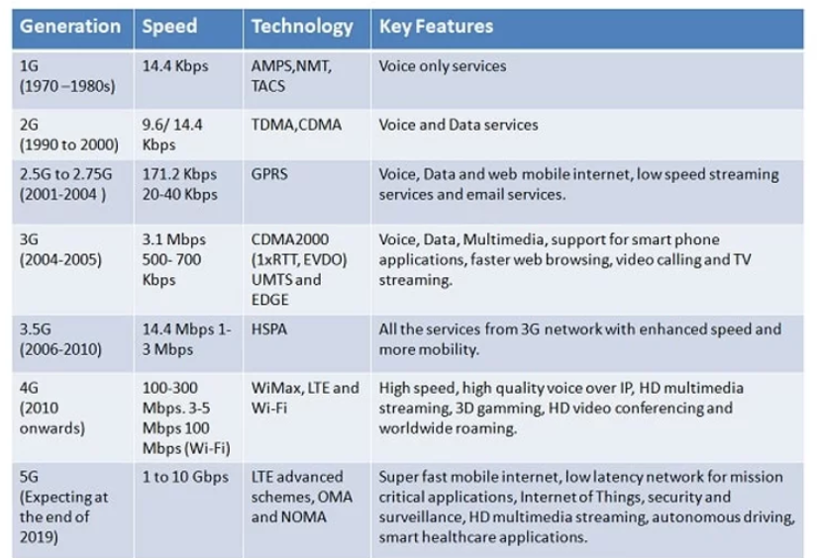

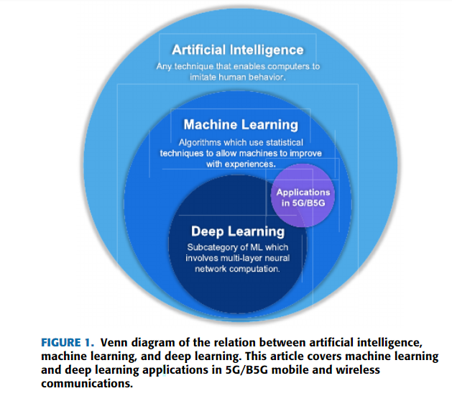

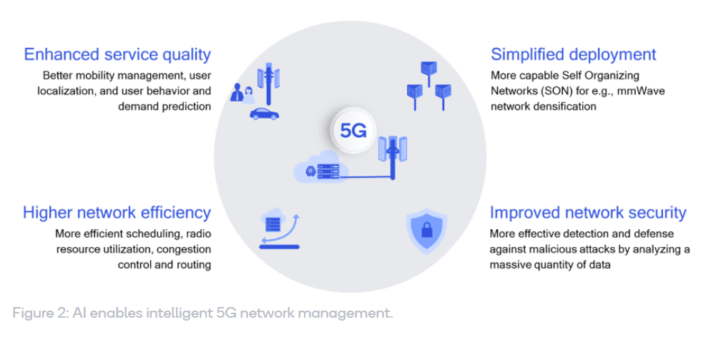

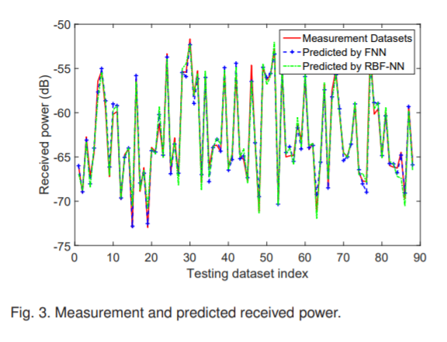 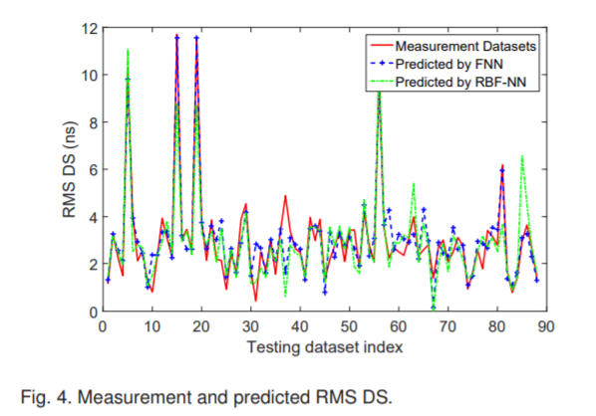

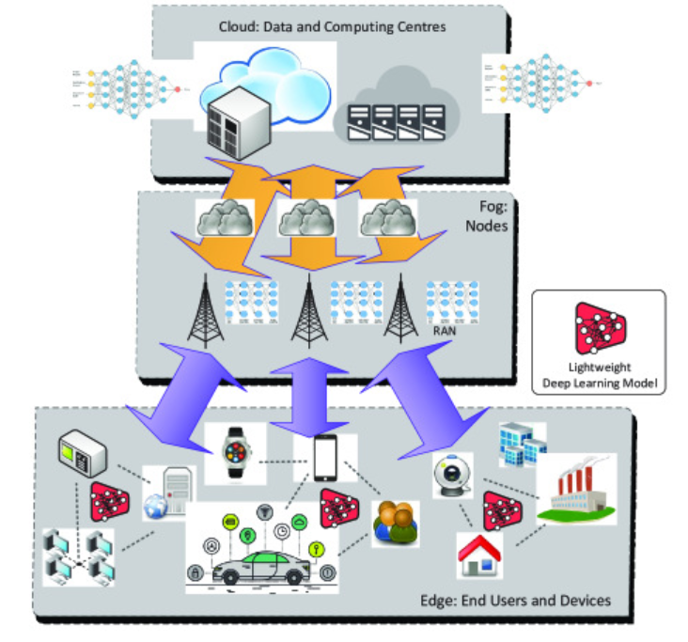

Fig.5: Application of deep learning in cloud, fog, and edge computing networks.

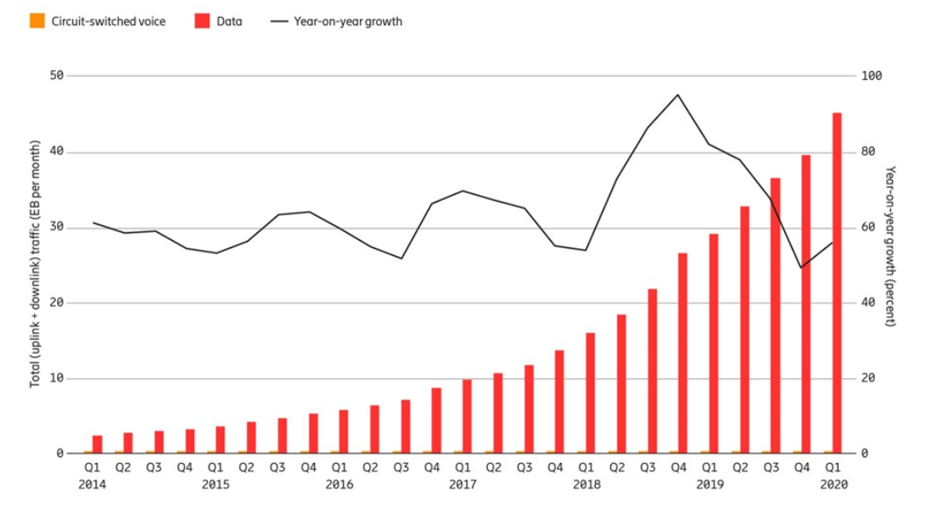

Fig 6: Global mobile network data traffic and year-on-year growth (does not include DVB-H, Wi-Fi)

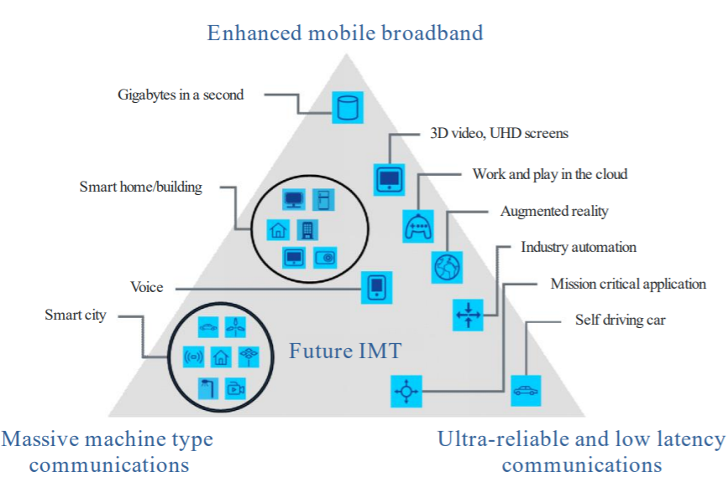

Fig.7: Network capability Requirements

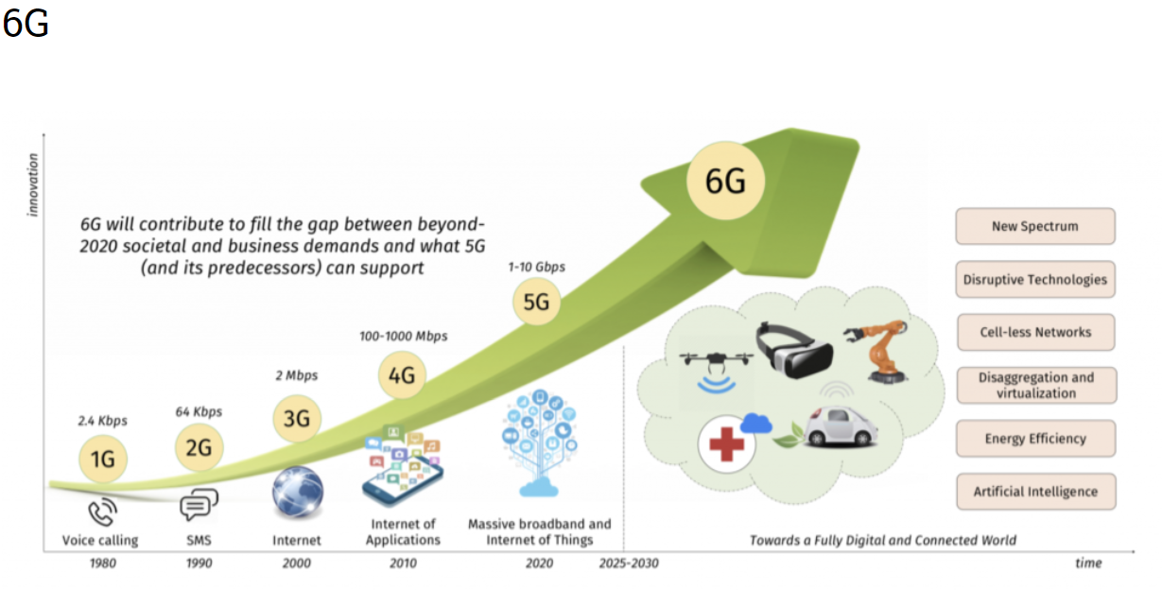

Fig.8

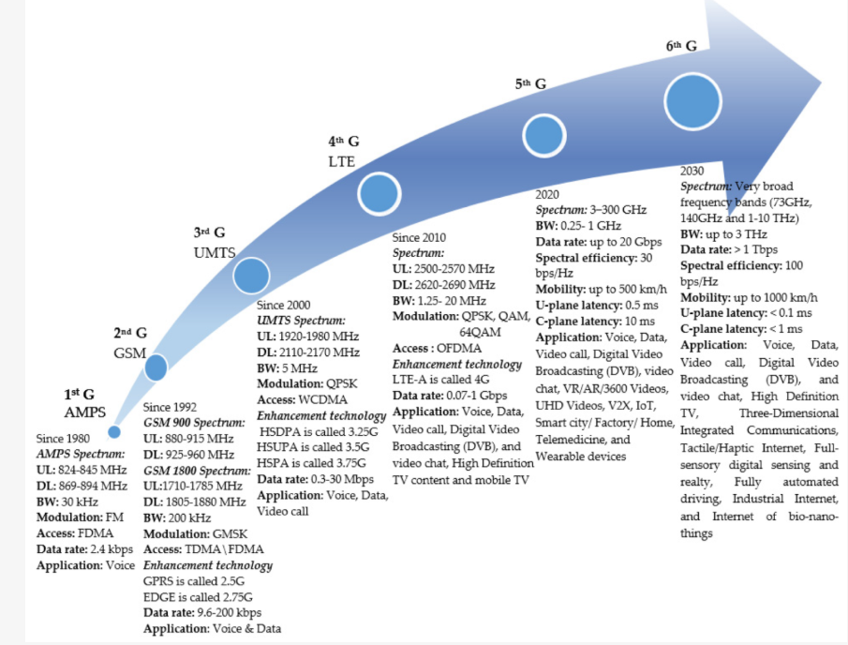

Fig.9: Major milestones for different generations of communications (1–6G).

1. <https://www.hindawi.com/journals/wcmc/si/758756/>
2. <http://www.bigdatanalysis.com/artificial-intelligence-overview/>
3. <https://www.javatpoint.com/difference-between-artificial-intelligence-and-machine-learning>
4. <https://medium.com/ai-in-plain-english/artificial-intelligence-vs-machine-learning-vs-deep-learning-whats-the-difference-dccce18efe7f>
5. <https://towardsdatascience.com/clearing-the-confusion-ai-vs-machine-learning-vs-deep-learning-differences-fce69b21d5eb>
6. <https://donesafe.com/2018/05/what-is-the-difference-between-artificial-intelligence-and-machine-learning/>
7. <https://www.ericsson.com/en/networks/offerings/network-services/ai-report>
8. <http://eprints.staffs.ac.uk/5526/1/Accepted_Manuscript_Nawaz_et_al_2019_IEEE_Access.pdf>
9. <https://www.researchgate.net/publication/278798179_Internet_of_Things_Applications_-_From_Research_and_Innovation_to_Market_Deployment>
10. <https://www.researchgate.net/publication/335937022_Machine_Learning_for_5GB5G_Mobile_and_Wireless_Communications_Potential_Limitations_and_Future_Directions>
11. <https://www.researchgate.net/publication/329495369_Artificial_Intelligence_in_5G_Technology_A_Survey>
12. <https://www.researchgate.net/publication/335021497_Beyond_5G_The_Role_of_THz_Spectrum>
13. <https://ieeexplore.ieee.org/abstract/document/7792374>
14. <https://www.researchgate.net/publication/3121923_Propagation_Prediction_Models_for_Wireless_Communication_Systems>
15. <https://www.researchgate.net/publication/299433749_On_the_Clustering_of_Radio_Channel_Impulse_Responses_Using_Sparsity-Based_Methods>
16. <https://deepai.org/publication/a-big-data-enabled-channel-model-for-5g-wireless-communication-systems>
17. <http://www.infocomm-journal.com/jcin/EN/article/downloadArticleFile.do?attachType=PDF&id=168964>
18. <https://ieeexplore.ieee.org/document/8284053>
19. <https://ieeexplore.ieee.org/document/8932164>
20. <http://www.ijcaonline.org/allpdf/pxc387893.pdf>
21. <http://www.theses.fr/2017LIMO0040/abes/2017LIMO0040.pdf>
22. <https://ieeexplore.ieee.org/document/8932164>
23. <https://ieeexplore.ieee.org/document/7742578>
24. <https://ieeexplore.ieee.org/document/8353153>
25. <https://ieeexplore.ieee.org/document/8398433>
26. <https://journals.sagepub.com/doi/full/10.1155/2015/785061>
27. <https://www.researchgate.net/profile/Yansheng_Li3/publication/319964354_Large-Scale_Remote_Sensing_Image_Retrieval_by_Deep_Hashing_Neural_Networks/links/59de64cbaca27247d79435fc/Large-Scale-Remote-Sensing-Image-Retrieval-by-Deep-Hashing-Neural-Networks.pdf>
28. <https://www.ncbi.nlm.nih.gov/pmc/articles/PMC7284607/>
29. <https://www.ncbi.nlm.nih.gov/pmc/articles/PMC7284607/>
30. <https://ieeexplore.ieee.org/document/7839093>
31. <https://ieeexplore.ieee.org/document/8284058>
32. <https://ieeexplore.ieee.org/document/6940305>
33. <https://ieeexplore.ieee.org/document/8553655>
34. <https://www.sciencedirect.com/science/article/pii/S0167926019301762>
35. <https://www.ericsson.com/en/mobility-report/reports/june-2020/mobile-traffic-q1>
36. <https://techjury.net/blog/how-much-data-is-created-every-day/#gref>
37. <https://www.intechopen.com/books/industry-4-0-current-status-and-future-trends/industry-4-0-current-status-and-future-trends>
38. <https://www.nytimes.com/2018/03/15/technology/saudi-arabia-hacks-cyberattacks.html>
39. <https://www.researchgate.net/publication/327046179_Network_Slicing_for_5G_Challenges_and_Opportunities>